Predicting FIFA World Cup 2026 Match Outcomes
HIT140 Foundations of Data Science | Assessment 3 | Group 5
Ashim Koirala – S407089
Aadesh Bhandari – S404328
Aditya Banstola – S403120
Sandesh Regmi – S407215

1. Project purpose and dataset

The purpose of this project is to investigate how effectively match outcomes may be predicted based on the knowledge of variables obtained prior to kick-off. We developed two regression models. The model 2.1 predicts the goal difference of a match and employs one row for each match, whereas the model 2.2 predicts the number of goals scored by one of the teams and uses two rows per match. The planned sizes of data sets are 104 matches and 208 team-match observations respectively. Match IDs serve the identification purpose only and are not used as predictors.

The predictors concentrate on previous performance and match context, but not on match statistics. At the beginning of a tournament, some teams have little or no tournament history at all. Assigning zero in such cases would lead to distorted perception of their skills and a smoothed version, taking into account the tournament average, is needed. It should be mentioned that FIFA ranking data available in the draft were not applicable for the analysis.

2. Predictor design and modelling approach

The two models employ distinct predictors as their estimations of different outcomes are involved. The largest coefficients, according to the coefficient chart of Model 2.1, include the ranking of team A on the FIFA list of rankings, team B's ranking and team B's winning ratio lately. The other variables include the teams' statistics of scoring and conceding and other factors related to the context of a match. In case of Model 2.2, the largest coefficients include those of the average goal difference of the team and the average goal difference of the opponent recently, as well as the number of the goals scored in the last match of the opponent and his loss ratio recently.

The matches are arranged in chronological order, and thus, the earlier matches can serve as training data while the latter – as testing data. It is more realistic and prevents the use of future data to predict past events. The draft also includes rolling backtests along with the simple baseline prediction based on the average value in the training set. RMSE and MAE serve as metrics of error, and R² as the variation explained.

3. Results: Model 2.1 — goal difference

The first graph demonstrates the relationship between each actual goal difference and its predicted value. An exact prediction should have the point that lies on the dashed diagonal. But points are distributed very widely around this line. There are games with a highly negative goal difference that get predicted closer to zero; there are also positive goal differences that are also off the mark. Therefore, this model does reflect certain tendencies, but its predictions are not precise enough.

In the draft, adjusted R² was 0.28, the model passed the test, and overall results were statistically significant. But the test results look rather disappointing: on the 21-game hold-out sample, RMSE is 1.95 while the baseline (average prediction) gives 1.75 RMSE. The winner of the game is predicted correctly in 42% of all non-draw games. On the rolling backtest, RMSE is 1.89 compared to 1.96 for the baseline (the baseline is slightly worse). Given that the confidence interval contains no improvement at all, the evidence that this model will be able to predict future games better than a simple average is weak.

4. Results: Model 2.2 — team goals scored
Secondly, as can be seen from the second graph, the majority of predictions lie between 1 and 2 goals. This means that the model prefers to predict normal scores rather than extremes. Teams that do not score any goals receive a positive prediction, whereas those who score four and five goals receive an underprediction. From this graph, we see that the model finds it difficult to cover all types of scores.
For Model 2.2, according to the draft, the adjusted R² value in training is equal to 0.13. On the hold-out data, RMSE equals 1.51 and is greater than the baseline's 1.32. In the rolling backtest, the results are similar – 1.34 for the model and 1.29 for the baseline. Recent goal difference form and opponent's recent form display the largest coefficients, although this does not mean the better test results for the model. Moreover, another issue with ordinary linear regression is that it can predict a negative number of goals..

5. Interpretation, limitations and improvements

Both approaches are able to capture some trends in the training data, but no one outperforms the average prediction model on test games. Making football predictions is quite complicated due to the fact that a small training dataset doesn't contain all the factors influencing the game. Graphs also show that predictions become less accurate when it comes to unusual number of goals scored and goal difference.

From the discussion part of the draft concerning alternative models, it becomes clear that using ridge regression helps to decrease the rolling RMSE of the models. Alternative models with just four variables work well in predicting goal difference. When we need to predict team goals, we can use Poisson regression approach since it is aimed at count data and the prediction will always be non-negative. The rolling RMSE of the Poisson regression is 1.25 against 1.29 of the average prediction model. Alternatives need to be evaluated using the training data and rolling validation while the hold out sample is used for final assessment..

6. Conclusion and data-quality check

In general, the findings seem to suggest that ordinary linear regression does not have sufficient predictive accuracy to estimate the outcome of individual World Cup matches. Model 2.1 has better performance than the baseline in the rolling test, but worse performance in the hold-out test. Model 2.2 has worse performance than the baseline in both of the reported tests. Ridge regression and Poisson regression could be considered as potential alternatives, although their performance needs to be further assessed.

There is one problem in the data that has to be addressed before submitting the assignment. According to the draft, there were four penalty shoot-outs omitted, and therefore 100 matches left. However, the assignment specifies that there must be 104 matches for Model 2.1 and 208 team-matches for Model 2.2. Make sure you have the right number of rows in your final dataset. Besides, make sure there are exactly eight independent variables in each model, with no more than four common variables.

Figures
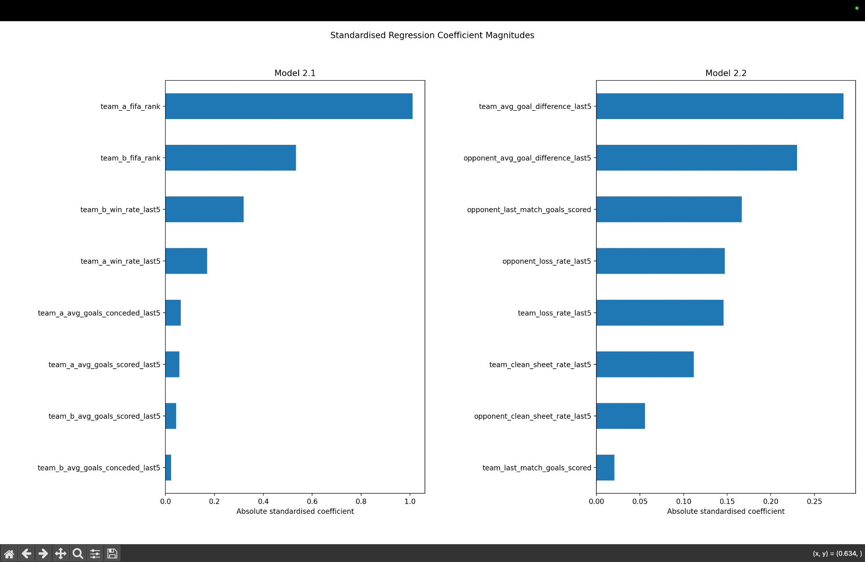
Figure 1. Absolute standardised coefficient magnitudes for the predictors displayed for each model.
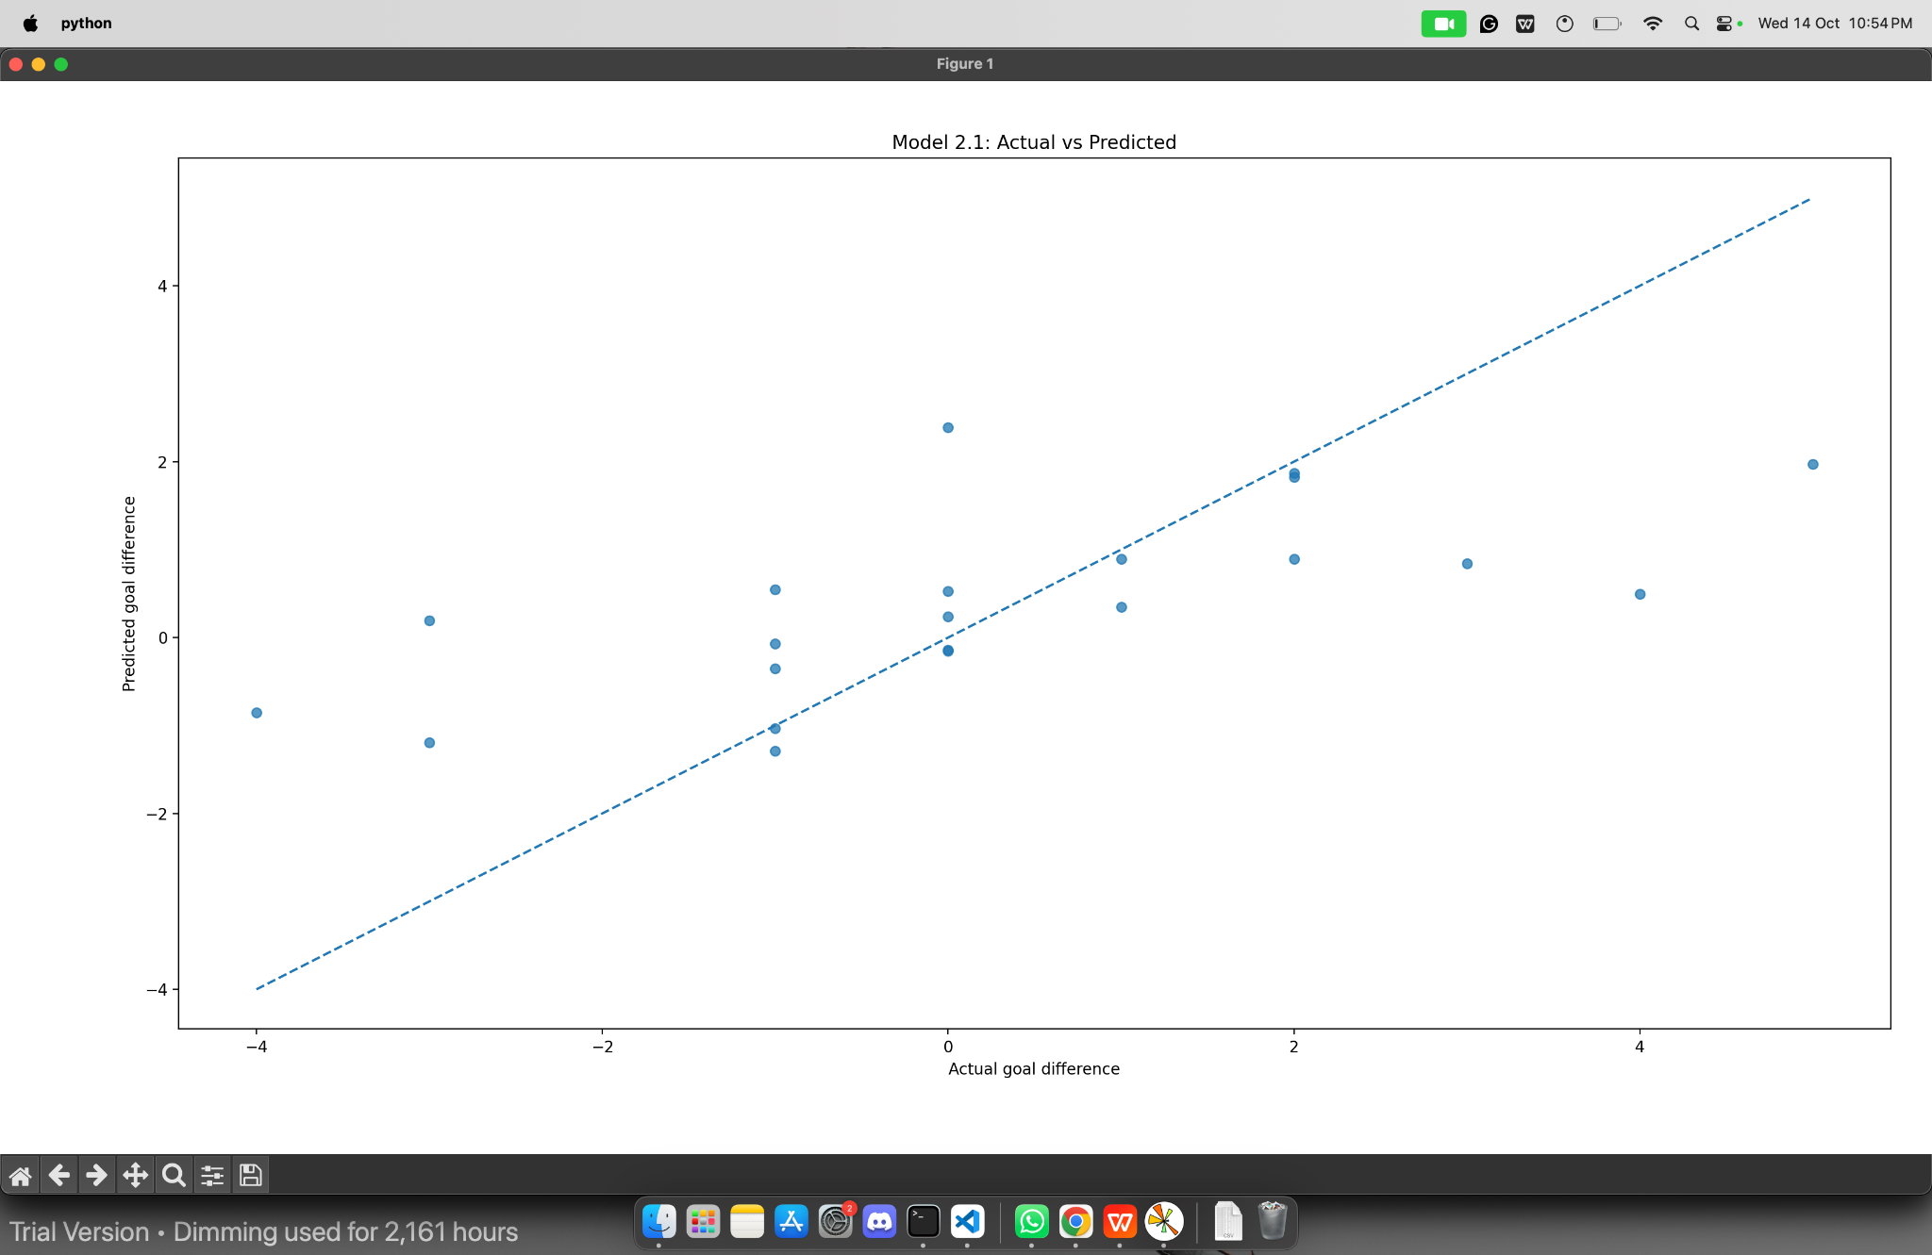
Figure 2. Model 2.1: actual versus predicted goal difference; the dashed line marks perfect prediction.
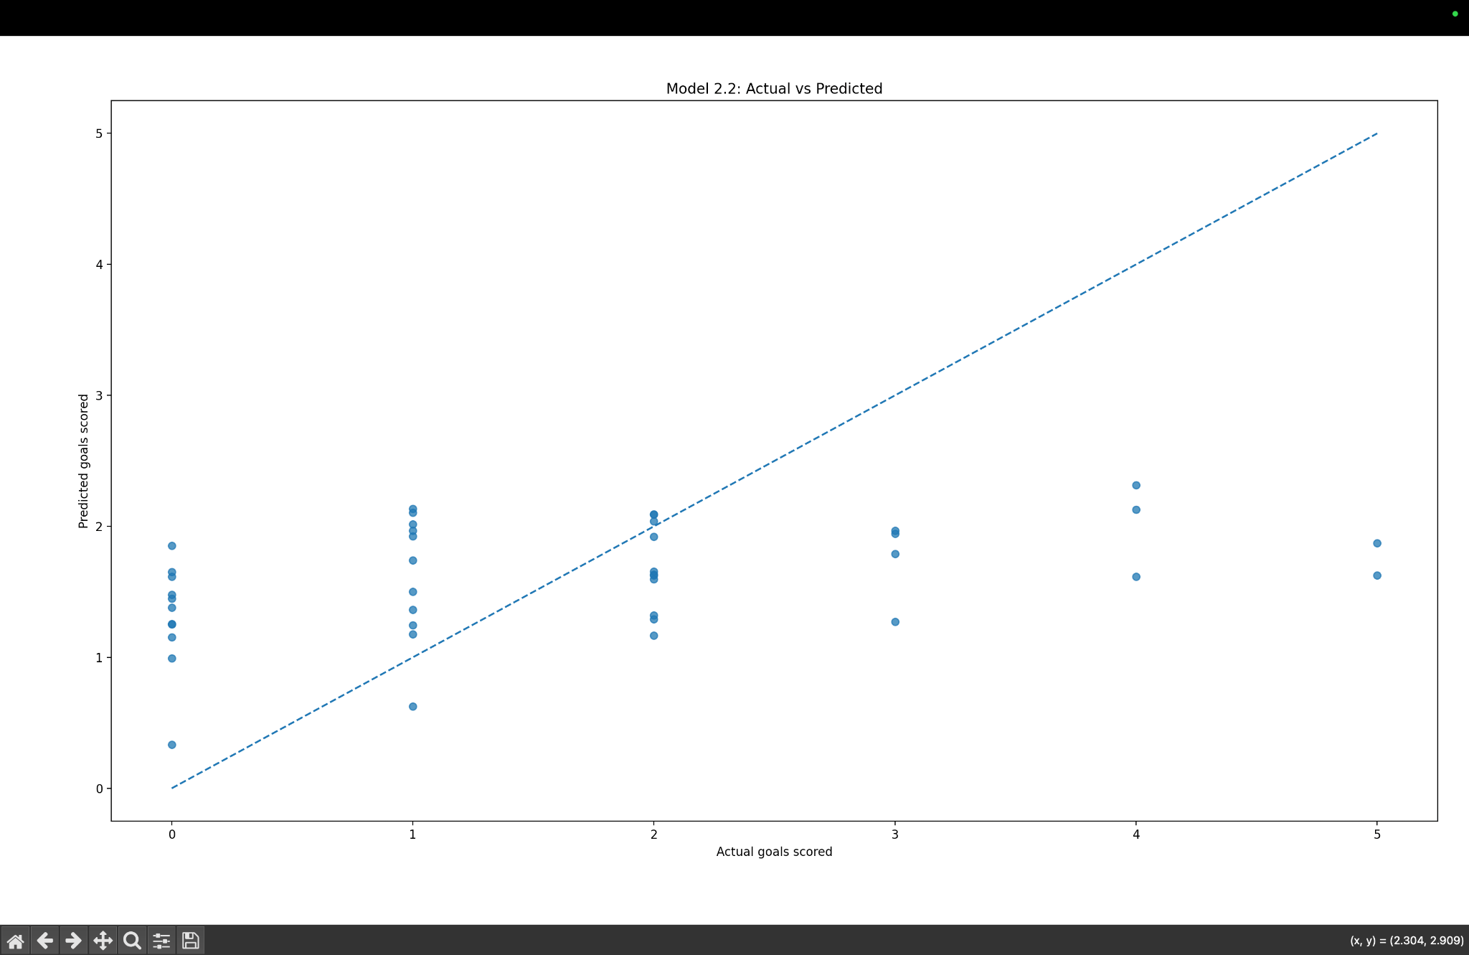
Figure 3. Model 2.2: actual versus predicted team goals; the dashed line marks perfect prediction.

